BUDDHI M. PERERA BA, BTEC HND
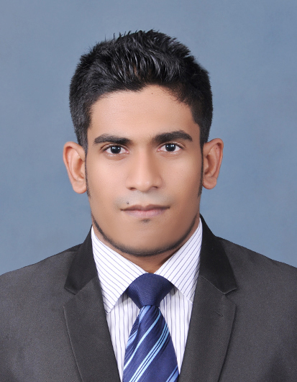
Areas of Expertise
Technical and operational side of International Trade
Interpersonal communication.
Relationship management.
Presentation and public speaking.
Personal Skills
Good Sense of Humor
Friendly and polite
Professional attitude
Professional
BA H International Business Management

Certified marketer in institute of marketing in Sri Lanka.

Professionally qualified in Resource management (Specialized in Learning and development)

Personal Details

M.K .B.M. Perera
421/C Maharanugegoda, Kadawata
T: +94 0112920940
M: +94 0718778245
E: buddhima12@gmail.com

Nationality – Sri Lankan

International Trade & Finance | Banking | Business Development | Market Analysis | Import/Export Sales & Marketing

T: +94 112 920 940, +94 718 778 245 • E: buddhima12@gmail.com

I am a loyal, energetic and highly motivated professional with over 6 years of progressive experience within the Banking and Finance industry. I am currently employed as an International Trade Associate at one of the largest and leading Financial Institutions in Sri Lanka where my experience and exposure to both the technical and operational side of International Trade, Finance and Business Development is unparalleled, both in terms of scale and diversity.
I consider my interpersonal and communication skills, management prowess and ability to multi-task and work well collaboratively with many others as among my greatest strengths. My desire to challenge myself further in a more dynamic and mature market such as the Middle East has led me to seek an Executive role at your esteemed organization where I can capitalize my skill and past experience while adding to your continued growth and success.
• Inventory Management • Administration • Communication & Presentation Skills • Advanced IT & Computer Skills •
• Customer Service Experience • Strong Interpersonal Skills • Relationship Management • Team Working Skills •
• International Trade Documentation • Excellent Attention to Detail • Conflict Resolution • Listening Skills
PROFESSIONAL EXPERIENCE
HATTON NATIONAL BANK (HNB) | COLOMBO – SRI LANKA | 2010 – to date
International Trade Associate (Import Document Disembarkation)
- I am entrusted with handling multiple operational tasks within International Trade and Import Documentation for one of Sri Lanka’s largest financial institutions—a mammoth task considering the scale of our operations and reach of our portfolio base from retail and SME clients to large scale public quoted conglomerates.

- Working in tandem with customer relations, trade services and upper management; I consistently maintain a hands-on, engaged approach in managing operational procedures and documentation relating to import trades.

- This gainful role has pushed me beyond my comfort zone and greatly challenged my core-communication and interpersonal skills while honing my leadership and management prowess through the myriad opportunities I am afforded to make key decisions under strict time and resource constraints.

HSBC | COLOMBO – SRI LANKA | 2010
Business Development Officer
- I began my career within banking and finance at one the largest financial powerhouses in the world where I was exposed to multiple aspects of business development and strategy; both on a local as well as on a global level.

- This initial role was instrumental in piquing my interest and passion for a career within international trade and finance while also developing my knowledge and in-depth understanding of the banking sector as whole.

ACADEMIC BACKGROUND
BA H International Business Management
Specialized in Entrepreneurship and Innovation.
University of Greenwich, UK | 2016
•
Elite Member
Sri Lanka Institute of Marketing (SLIM) | 2016
•
Human Resource Management (Personal Development Consultancy)
EdExcel B-Tech (Level 5), UK | 2015
•
GCE Advance Level Examination (Distinctions in Physics, Chemistry & Biology)
Wesley College Colombo, Sri Lanka | 2010
•
GCE Ordinary Level Examination (Distinctions in English, Mathematics & Science)
Wesley College, Colombo | 2005
ACTIVITIES AND ACHIVEMENTS
- A keen Chess enthusiast; I was adjudged Runner up in a Junior Chess World Championship conducted by the Anatoly Karporch Organization.
- An accomplished Swimmer and school swimming team member; I was recognized as the Champion Swimmer during an inter-school meet held in Colombo, Sri Lanka.
- A prolific public speaker; I have been actively involved with Toastmasters International.

• • • Referees Available on Request • • •

